1.（1）The main and most basic function of the Make tool is to describe the relationship between source programs and automatically maintain the compilation work through makefiles.

（2）When the make command is first executed, it scans the makefile to find the target and its dependencies. If these dependencies are targets themselves, continue to scan the makefile for these dependencies to build their dependencies and then compile them. Once the main dependencies are compiled, the main target is then compiled.

（3）make compile, directly execute make, generate .o files, and target executable files.

2. Yes, chsh allows you to change your default login shell. It prompts you for the full pathname of the new shell, which is then used as your shell for subsequent logins.

3. Internal commands are part of the shell program.

External command is the utility part in linux system.

The biggest difference between internal commands and external commands is performance. Internal commands execute much faster than external commands because they are built into the shell and do not have to create extra processes.

4. tar zcvf test.tar $( find $HOME -mtime -2)

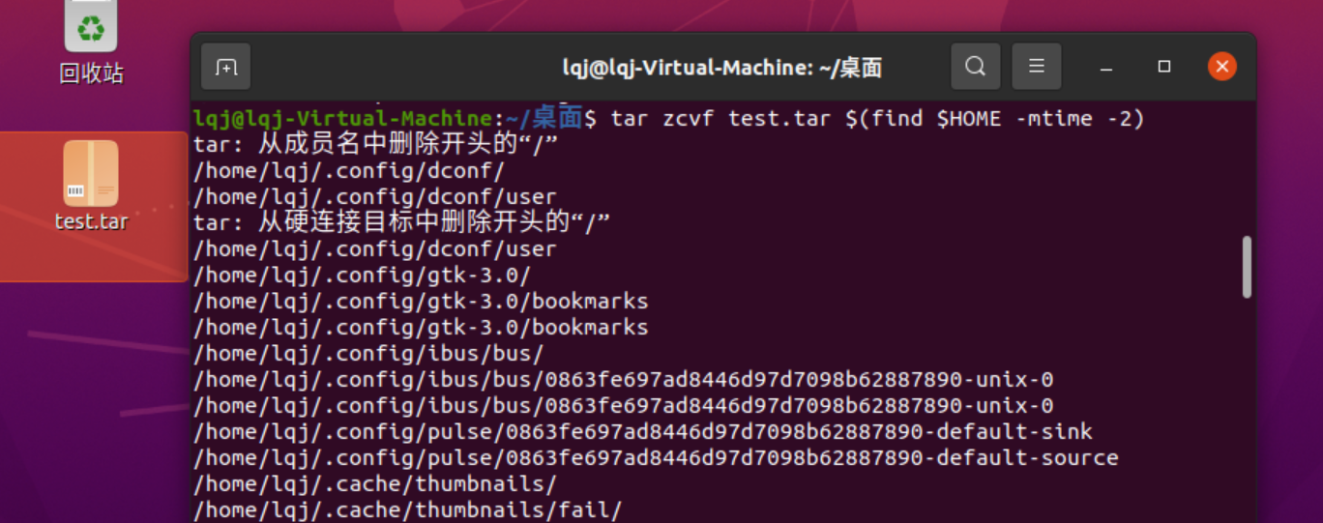

5. ‘’: None of the characters enclosed in ‘’ have special meaning.

``: The function of ``is command substitution. The content in backticks (``) is usually the command line. The program will execute the content in backticks first, and replace the content in backticks with the running result.

6.echo $PATH

If it isn't a built-in command or a full pathname, the shell searches the directories whose names are stored in the PATH environment variable.

7.(1) Perl: a feature-rich computer programming language.

Shell: Interpret and execute commands entered by the user interactively or automatically interpret and execute a series of pre-set commands.

I feel that shell is more suitable for writing automated build scripts and system management scripts; Perl is suitable for writing data processing and cross-platform applications

(2) Yes, Shell is a scripting language, the shell language is a logical combination of a bunch of binary commands. The shell program interprets the logical relationship and conveys it to the kernel. And C language is a high-level computer language, It is directly translated into binary instructions by the gcc compiler, so it is more efficient.